Data processing report

Data modelling
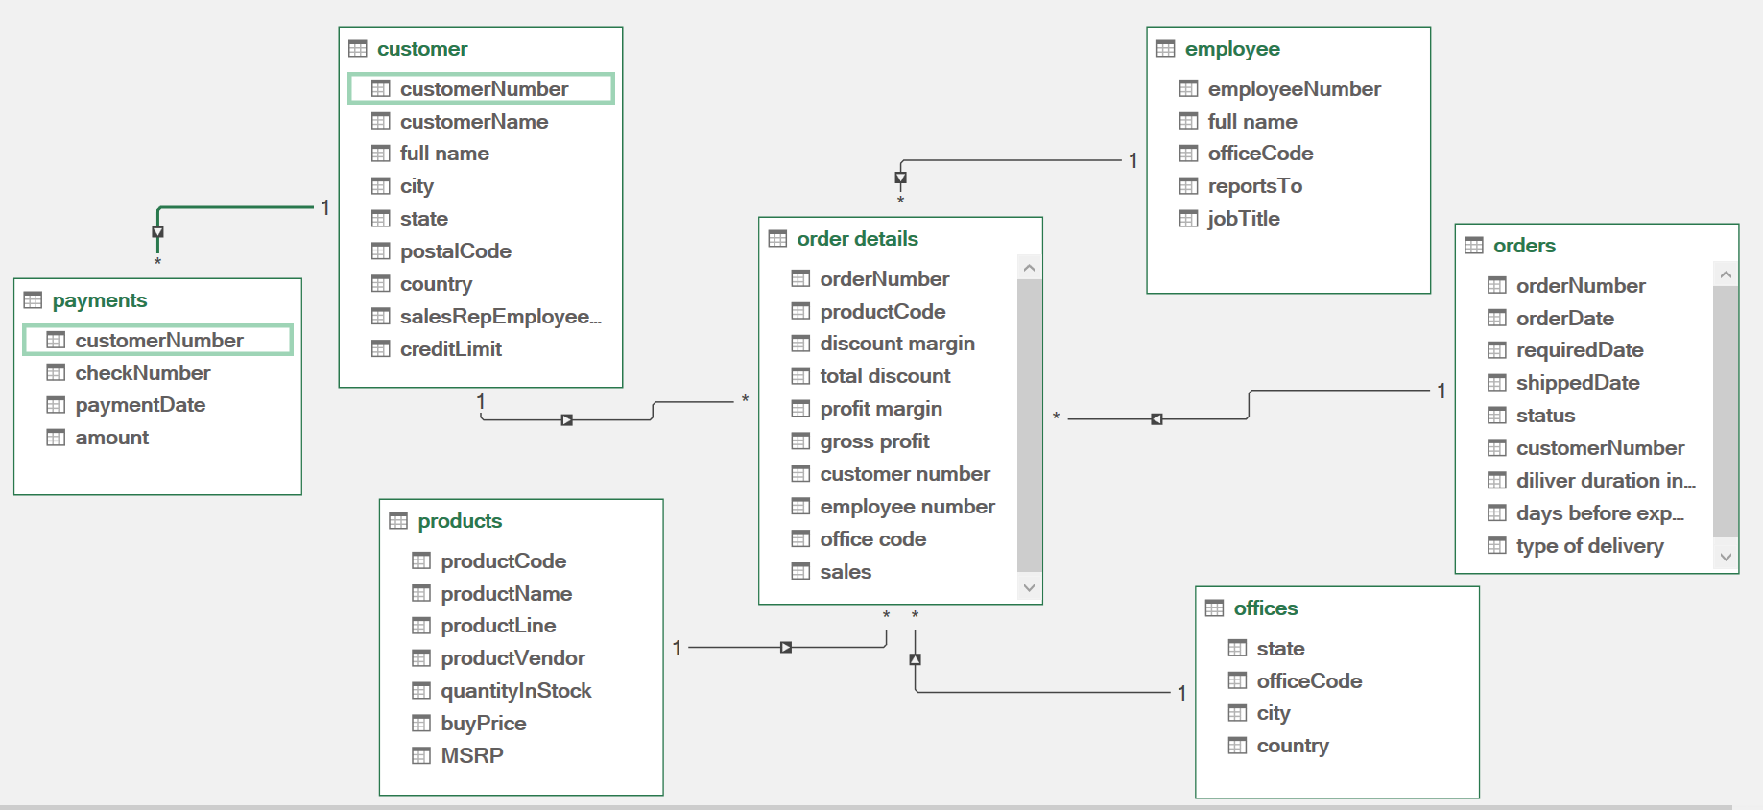
11. Data Cleaning & Transformation (Power Query)
This section outlines the data preprocessing and transformation steps applied using Power Query to ensure data quality, consistency, and analytical readiness.

11.1 Customer Table Cleaning
The following transformations were applied to the customer dataset:
Handling Missing Values
- Replaced "NULL" values with actual null values in:
  - state
  - addressLine2
  - postalCode
Data Type Corrections
- Converted:
  - customerNumber → Integer
  - creditLimit → Integer
  - salesRepEmployeeNumber → Integer
Column Transformations
- Created a new column:
  - full name = contactFirstName + contactLastName
- Removed unnecessary columns:
  - addressLine1, addressLine2, phone
Impact
- Improved usability of customer identity fields
- Reduced redundancy and optimized dataset size
- Prepared data for customer-level aggregation

11.2 Employee Table Cleaning
Data Type Standardization
- Converted employeeNumber and officeCode to numeric types
Handling Missing Values
- Replaced "NULL" in reportsTo with null
Column Transformations
- Created:
  - full name (first + last name)
- Removed:
  - email, extension
Impact
- Simplified employee hierarchy structure
- Enabled easier mapping with customers and offices

11.3 Office Table Cleaning
Column Reduction
- Retained only relevant fields:
  - officeCode, city, state, country
Impact
- Focused dataset on geographic analysis
- Removed unnecessary address-level noise

11.4 Orders Table Transformation
Data Type Fixes
- Converted:
  - orderDate, requiredDate, shippedDate → Date format
Derived Metrics
- Delivery Duration
- shippedDate - orderDate
- Days Before Expected Delivery
- requiredDate - shippedDate
Delivery Classification
Created type of delivery:
- same day
- early
- late delivery
- cancelled (when shipped date is null)
Column Removal
- Dropped comments
Impact
- Enabled operational efficiency analysis
- Provided key logistics KPI (delivery performance)

11.5 Order Details Table (Major Transformation Layer)
This is the core analytical table, where multiple joins and calculations were performed.
Data Enrichment via Joins
- Joined with:
  - Products → to get buyPrice, MSRP
  - Orders → to get customerNumber
  - Customers → to get salesRepEmployeeNumber
  - Employees → to get officeCode
Feature Engineering
Discount Metrics
- Discount Margin:
- MSRP - PriceEach
- Total Discount:
- Discount Margin × Quantity Ordered
Profit Metrics
- Profit Margin:
- PriceEach - Buy Price
- Gross Profit:
- Profit Margin × Quantity Ordered
Sales Estimation
- Sales:
- Gross Profit ÷ Profit Margin
(equivalent to total revenue)
Column Optimization
- Removed:
  - MSRP, buyPrice, quantityOrdered, priceEach, orderLineNumber
Impact
- Created a fact table for analysis
- Enabled revenue, discount, and profit analysis
- Connected sales data across customers, employees, and regions

11.6 Payments Table Cleaning
Data Type Conversion
- Converted:
  - customerNumber → Integer
  - paymentDate → Date
  - amount → Numeric
Impact
- Prepared for financial aggregation
- Limitation remains: no direct linkage to orders

11.7 Products Table Cleaning
Column Removal
- Removed:
  - productDescription
Data Type Standardization
- Ensured numeric consistency for:
  - buyPrice, MSRP, quantityInStock
Impact
- Reduced dataset size
- Maintained focus on analytical attributes

12. Data Integration Summary
After cleaning, the dataset was transformed into a relational analytical model:
- Fact Table
  - Order Details (enhanced with revenue & profit)
- Dimension Tables
  - Customers
  - Products
  - Employees
  - Offices
  - Orders
This structure supports:
- Star-schema-like modeling
- Efficient dashboard performance
- Scalable analytics

13. Additional Enhancements (Recommended Additions)
To further strengthen the analysis, the following improvements are recommended:
Customer Intelligence
- Create:
  - Customer Lifetime Value (CLV)
  - Customer Segmentation (High / Medium / Low value)
  - Recency (Last purchase date)
Time-Based Analysis
- Extract:
  - Year, Quarter, Month from order dates
- Enable:
  - Trend analysis
  - Seasonality insights
Data Quality Improvements
- Standardize:
  - Country and state names
- Validate:
  - Negative or zero values in financial fields
Business Logic Enhancements
- Define:
  - Profit thresholds
  - Discount impact analysis
- Add:
  - Order frequency per customer

14. Key Outcomes of Data Preparation
- Transformed raw CSV files into analysis-ready datasets
- Created revenue, profit, and discount metrics
- Built cross-table relationships for deep insights
- Enabled customer, product, and regional analytics
- Established foundation for dashboarding and modeling

